If You Are Abused  By your partner, you may feel confused, afraid, angry and/or trapped. Your partner may try to blame you or make you feel, what is happening is your fault. All these emotions are normal responses to abuse. But no matter what others might say, you are never responsible for your partner’s abusive actions. No one deserves to be battered.  Myth 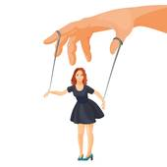 Reality  Abuse is caused by stress Abuse is a chosen  substance abuse, or behavior to gain power  mental health issues. and control over you  STAY SAFE  If you are in a violent relationship, your first  priority is to get yourself and your children to  safety. Statistics show that the most dangerous  time is when the victim tries to leave the relationship. Seek refuge in an environment where the abuser cannot find you. Do not go to your parents’ home, a best friend’s house, or anywhere that the abuser will go/possibly look for you at. | Are You or Someone You Know in an Abusive Relationship?  There are many signs to look for to determine if you are being abused, some more serious than others. For instance, does your partner:  - Call you names or put you down?  - Look at you or act in ways that scare you?  - Control what you do, who you see or talk to or where you go?  - Stop you from seeing your friends or  family members?  - Make all of the decisions?  - Tell you that you’re a bad parent or threaten to take away or hurt your children?  - Prevent you from working or attending school?  - Intimidate you with guns, knives or  other weapons?  - Shove you, slap you, choke you or hit you?  - Threaten to commit suicide?  - Threaten to kill you?  Please be honest with yourself !  Stop Ignoring the problem, It will not  Go away unless YOU put a STOP to IT ! | It’s never ok  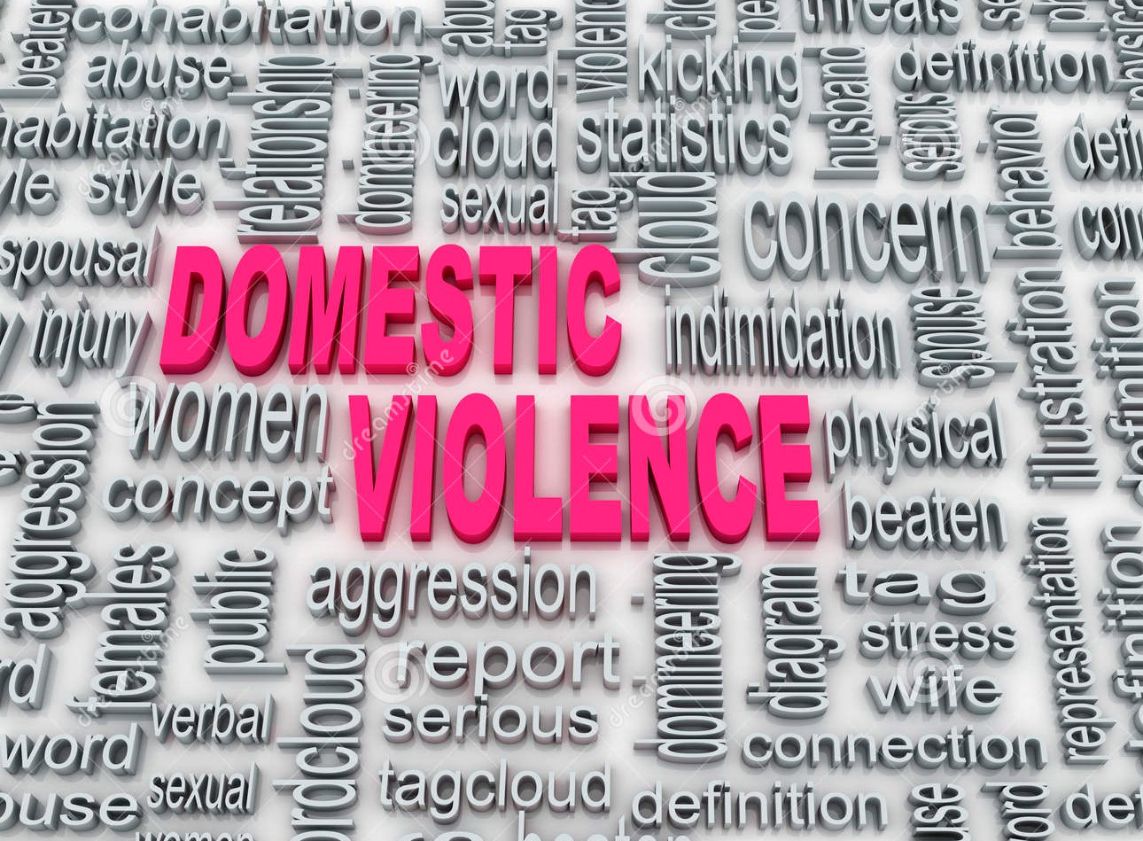  Roughly 1 in 4 Women & 1 in 7 Men  have or will experienced  domestic violence in an  intimate relationship.  Everyone has the right to be SAFE in their own HOME……
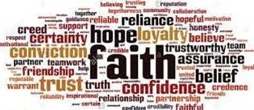 | 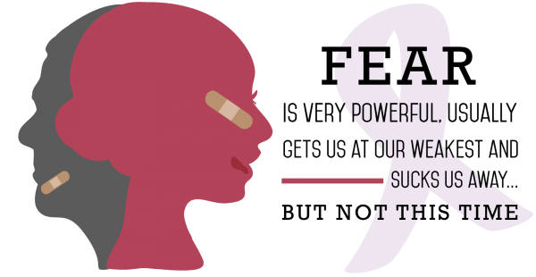 | - Seventy Times Seven Center  1-800-893-9658  Email: seventytimesevencenter@gmail.com  Website:  seventytimessevencenter.com
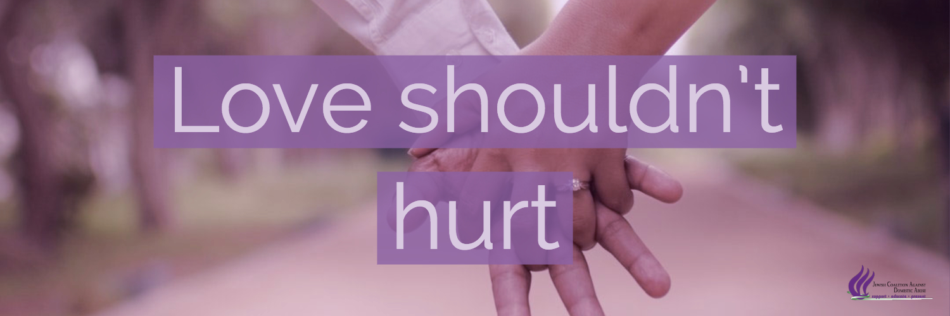  WHAT IS DOMESTIC VIOLENCE?  Domestic violence is aggressive, controlling,  and abusive behavior that can include verbal,  emotional, and physical abuse. Both men and women can be victims of domestic violence and can abuse their partners as well. It is a pattern of behaviors used by one person to gain power and control over another person in an intimate relationship. It occurs in married and unmarried relationships, and among people of all racial, ethnic, economic, educational, and religious backgrounds and sexual orientations.  Without help, THIS will get severely worse over time. It can even get DEADLY !!  We are here to help!  Call 911, Seventy Times Seven Center, go to a Church, or just report it ! | Emotional, Verbal and Psychological Abuse  - Constant insults, ridicule or name calling  - Repeated threats of violence or death to cause emotional pain  Economic Abuse  - Selling of shared property e.g. livestock, matrimonial house without the consent of a victim  - Accessing a joint bank account for personal use without the consent of a victim  Intimidation  - Sending written or verbal death threats to a victim  - Sending beheaded dolls, small coffins, dead flower or dead pets to a victim  Harassment  - Repeatedly watching a victim outside his/her home, school or workplace; or any other place frequently.  - Repeatedly phoning a victim, getting another persons to phone the victim.  Stalking  - Constantly approaching a victim and asking or demanding to talk to a victim against his/her will  Acts of Damage to Property  - Breaking a window to enter into a victim’s house  - Cutting, breaking or damaging any shared property  Unauthorized Entry  - Using a duplicate key to gain access may also constitute domestic violence | You Have Support  - Having some support Friends, Family, or Strangers can be very helpful as you plan for safety. There are many places you can turn to for assistance.  - Women’s and Community groups, Churches, and Service providers (such as legal, health, counseling centers) can give, guide or show you to the resources, support, and assistance that is HERE for YOU.  There are organizations  that provide free and  confidential help to  individuals who are  being abused.  Age, Gender, Sexual Orientation  Or Immigration Status does  not matter We will HELP. Just  reach out before it’s TOO LATE.

